**REGISTRATION FORM**

**SEMESTRAL FEES**

**PLAN**

**A**

REGISTRAR'S COPY

Kasiglahan Village, San Jose, Rodriguez, Rizal Tel No.: (02)2968667/ (02)3959731

Tuition Fee

Admission Fee

Athletic Fee

1,575.00

0.00

**LAST NAME**

**FIRST NAME**

**MIDDLE NAME**

<LNAME>

<FNAME>

<MI>

50.00

**STUDENT NUMBER**

**<SNUM>**

**COURSE**

**ACADEMIC YEAR**

**SEMESTER**

**YEAR LEVEL**

Computer Fee

Cultural Fee

1,000.00

75.00

BSIT

AY 2021-2022

2nd

3rd year-REGULAR

**CODE**

**SUBJECTDESCRIPTION**

**YEAR-SECTION**

**UNITS DAYS**

**TIME**

**ROOM**

Development Fee

Guidance Fee

300.00

100.00

0.00

ELECT 3 (IPT) ITElective3(IntegrativeProgrammingandTechnologies2)

BSIT3I

BSIT3I

BSIT3I

BSIT3I

BSIT3I

BSIT3I

BSIT3I

3

3

3

3

3

3

3

GE RIZAL

HC1

The Life and Works of JoseRizal

HumanComputerInteraction

IAS1

IM2

InformationAssuranceandSecurity1

Data Warehousing and Data Mining

QuantitativeMethods

Handbook Fee

Laboratory Fee

Library Fee

0.00

QM

SA

SystemAdministrationandMaintenance

500.00

75.00

Medical & Dental Fee

Registration Fee

School ID Fee

75.00

0.00

**TOTAL**

ASSESSED BY

Tracking no#.

**ADVISER**

**Total Units**

**REGISTRAR**

Engr. Rhona M. Segui

**3,750.00**

Patrolla03-16-22

**21**

**DATE**

Note:

*19-00627*

<EMAIL>

Designedby: TEAMMIS

ASSESMENTver. 2nd-19-20

**REGISTRATION FORM**

**SEMESTRAL FEES**

**PLAN**

**A**

Kasiglahan Village, San Jose, Rodriguez, Rizal Tel No.: (02)2968667/ (02)3959731

CASHIER'S COPY

Tuition Fee

1,575.00

**LAST NAME**

**FIRST NAME**

**MIDDLE NAME**

Admission Fee

Athletic Fee

0.00

<LNAME>

<FNAME>

<MI>

50.00

**STUDENT NUMBER**

**<SNUM>**

**COURSE**

**ACADEMIC YEAR**

**SEMESTER**

**YEAR LEVEL**

Computer Fee

Cultural Fee

1,000.00

75.00

BSIT

AY 2021-2022

2nd

3rd year-REGULAR

**CODE**

**SUBJECTDESCRIPTION**

**YEAR-SECTION**

**UNITS DAYS**

**TIME**

**ROOM**

Development Fee

Guidance Fee

300.00

100.00

0.00

ELECT 3 (IPT) ITElective3(IntegrativeProgrammingandTechnologies2)

BSIT3I

BSIT3I

BSIT3I

BSIT3I

BSIT3I

BSIT3I

BSIT3I

3

3

3

3

3

3

3

GE RIZAL

HC1

The Life and Works of JoseRizal

HumanComputerInteraction

IAS1

IM2

InformationAssuranceandSecurity1

Data Warehousing and Data Mining

QuantitativeMethods

Handbook Fee

Laboratory Fee

Library Fee

0.00

QM

SA

SystemAdministrationandMaintenance

500.00

75.00

Medical & Dental Fee

Registration Fee

School ID Fee

75.00

0.00

**TOTAL**

ASSESSED BY

Tracking no#.

**ADVISER**

**Total Units**

**REGISTRAR**

Engr. Rhona M. Segui

**3,750.00**

Patrolla03-16-22

**21**

**DATE**

Note:

*19-00627*

<EMAIL>

Designedby: TEAMMIS

ASSESMENTver. 2nd-19-20

**REGISTRATION FORM**

**SEMESTRAL FEES**

**PLAN**

**A**

STUDENT'S COPY

Kasiglahan Village, San Jose, Rodriguez, Rizal Tel No.: (02)2968667/ (02)3959731

Tuition Fee

Admission Fee

Athletic Fee

1,575.00

0.00

**LAST NAME**

**FIRST NAME**

**MIDDLE NAME**

<LNAME>

<FNAME>

<MI>

50.00

**STUDENT NUMBER**

**<SNUM>**

**COURSE**

**ACADEMIC YEAR**

**SEMESTER**

**YEAR LEVEL**

Computer Fee

1,000.00

BSIT

AY 2021-2022

2nd

3rd year-REGULAR

Cultural Fee

Development Fee

Guidance Fee

75.00

300.00

100.00

0.00

**CODE**

**SUBJECTDESCRIPTION**

**YEAR-SECTION**

**UNITS DAYS**

**TIME**

**ROOM**

ELECT 3 (IPT) ITElective3(IntegrativeProgrammingandTechnologies2)

BSIT3I

BSIT3I

BSIT3I

BSIT3I

BSIT3I

BSIT3I

BSIT3I

3

3

3

3

3

3

3

GE RIZAL

HC1

The Life and Works of JoseRizal

HumanComputerInteraction

IAS1

IM2

InformationAssuranceandSecurity1

Data Warehousing and Data Mining

QuantitativeMethods

Handbook Fee

Laboratory Fee

Library Fee

0.00

QM

SA

SystemAdministrationandMaintenance

500.00

75.00

Medical & Dental Fee

Registration Fee

School ID Fee

75.00

0.00

**TOTAL**

ASSESSED BY

Tracking no#.

**ADVISER**

**Total Units**

**REGISTRAR**

Engr. Rhona M. Segui

**3,750.00**

Patrolla03-16-22

**21**

**DATE**

**7**

Note:

*19-00627*

<EMAIL>

CdMFORMNO. 120

Designedby: TEAMMIS

<LNAME>

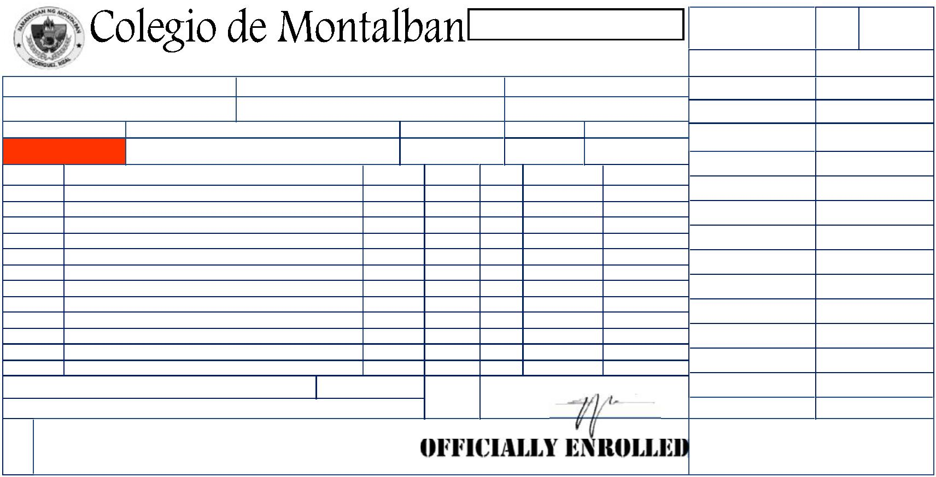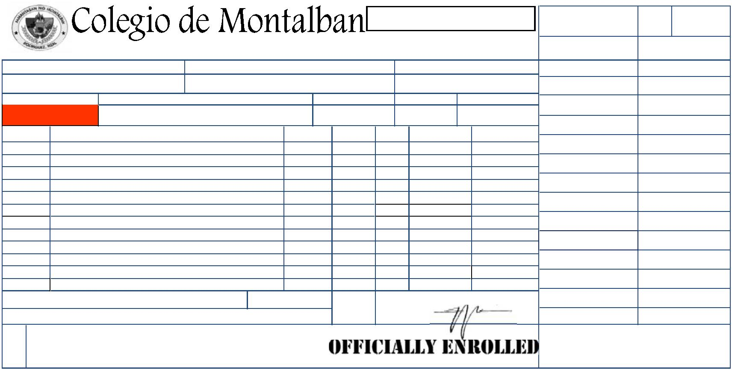ooxWord://word/media/image3.jpegooxWord://word/media/image4.jpegooxWord://word/media/image5.jpegooxWord://word/media/image6.jpegooxWord://word/media/image7.jpegooxWord://word/media/image8.jpegooxWord://word/media/image9.jpegooxWord://word/media/image10.jpeg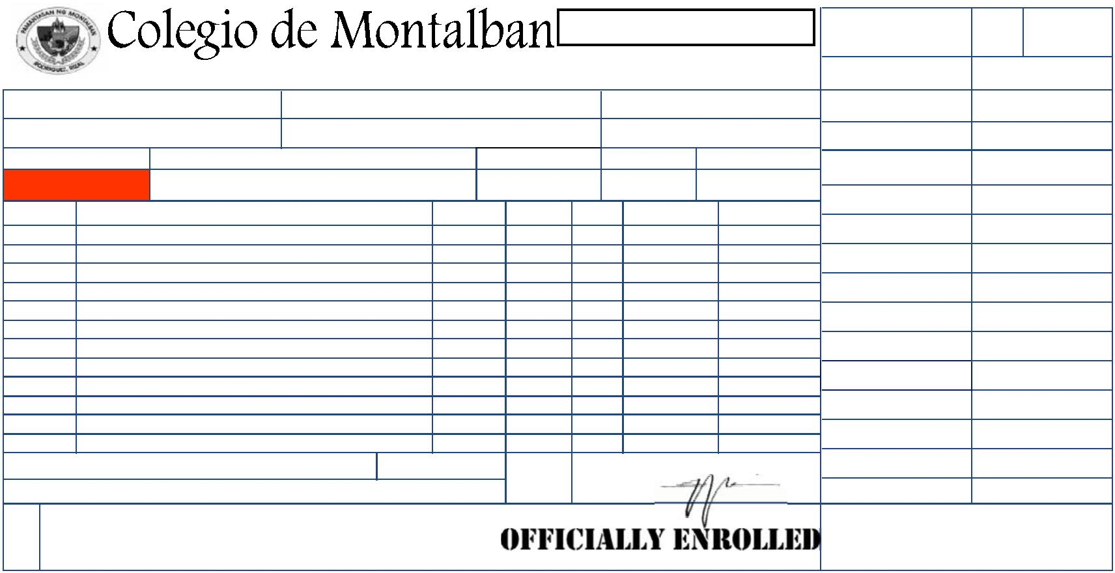ooxWord://word/media/image12.jpegooxWord://word/media/image13.jpegooxWord://word/media/image14.jpegooxWord://word/media/image15.jpegooxWord://word/media/image16.jpegooxWord://word/media/image17.jpegooxWord://word/media/image18.jpegooxWord://word/media/image19.jpegooxWord://word/media/image20.jpegooxWord://word/media/image21.jpeg